Project Plan NSW Traffic Penalty Data Analyser

Assignment part A: 2810ICT Software Technologies

Joshua Thomas - s5220078

Roger Harley - s5221666

Contents

**1.0** **Introduction** 2

**1.1** **Background** 2

**1.2** **Scope** 2

**1.3** **Document contents** 2

**2.0** **Work Breakdown Structure** 3

**2.1** **Work Breakdown Structure Data** 3

**2.2** **Work Breakdown Structure Diagram** 4

**3.0** **Activity Definition & Estimation** 5

**4.0** **Gantt Chart** 6

**5.0** **Bibliography** 7

1. **Introduction**
   1. **Background**

With well over 6 million registered vehicles within the state of NSW alone, the data constantly generated by every vehicle would be completely overwhelming for any human being to manually work with. The simple tasks of sorting, ordering and displaying data could take days, if not weeks, for someone to manually collect and organise the data. This problem can be alleviated through the use of computers to organize data, with specially wrote code to sort, analyse and display data to the user.   
Revenue NSW data reveals there were “3.2 million fines worth $907,376,871 issued between December 2020 and November 2021” (Noble, 2022). This means that over 3.2 million units of data were required to be sorted, analysed and stored in order to be useful to anyone in need, virtually impossible for someone perform manually. The data collected and processed can be used for many useful purposes, such as analysis, crime prevention, pattern analysis, etc.

* 1. **Scope**

The objective of this project is to compile a program that will perform a variety of operations on data collected from NSW traffic penalties to run on the computers of law enforcement. The developed program will produce visual representations, intelligent analysis, a user-friendly GUI and a way to filter and sort specific sets of data (by date, penalty type, time, location, etc). This project was initiated to provide those that need it a reliable and precise way to view trends, patterns and a detailed analysis into traffic infringements occurring on the roads of NSW in order for them to understand the trends of certain offences, locations and insights into rates of different penalties occurring. The program must be able to retroactively analyse data, rather than only analysing data collected once the program is fully integrated. This will ensure than any trends that have existed in the past, or are currently emerging will be able to be identified. This project will assume that currently operating way of storing penalty data is upheld, by this changing, it may severely impact the program by requiring a rework of the way data is captured by the program. It is also assumed that this project will receive any access level required to the data in order to perform the tasks required. If this assumption is not met, the program itself may not be able to function at all. Finally, it is to be assumed that every part of the project is thoroughly documented, tested and reviewed to endure proper accountability and functionality.

* 1. **Document contents**

*Include some background information about the problem, the scope and what this document will contain.*

1. **Work Breakdown Structure** 
   1. **Work Breakdown Structure Data**

**NSW traffic penalty data application**

|  |
| --- |
| 1. **Planning**     1. Define team communication channels    2. Resource analysis and procurement    3. Evaluating current systems    4. Develop project overview    5. Establishing project scope    6. Develop a work breakdown structure    7. Analyse the dataset    8. Develop a Gantt chart    9. Define the project scope |
| 1. **Design**    1. Develop a system vision statement    2. Define project requirements    3. Develop software use cases    4. Develop software misuse cases    5. Define system components    6. Define related software design    7. Define early user interface design    8. Develop a wireframe |
| 1. **Software Development**     1. Software unit allocations    2. Software prototyping    3. Software design progress reports    4. Software unit coding    5. Software unit debugging    6. Software unit incorporation    7. Integrated software testing    8. Major software finalization and publishing |
| 1. **Implementation**     1. Integration testing    2. Staff training    3. GUI finalizations    4. Installation performance monitoring    5. Bug fixes    6. User support documentation    7. Software support documentation |
| 1. **Closure**    1. Project finalization report    2. Team discussions    3. Team dispersion |

* 1. **Work Breakdown Structure Diagram**

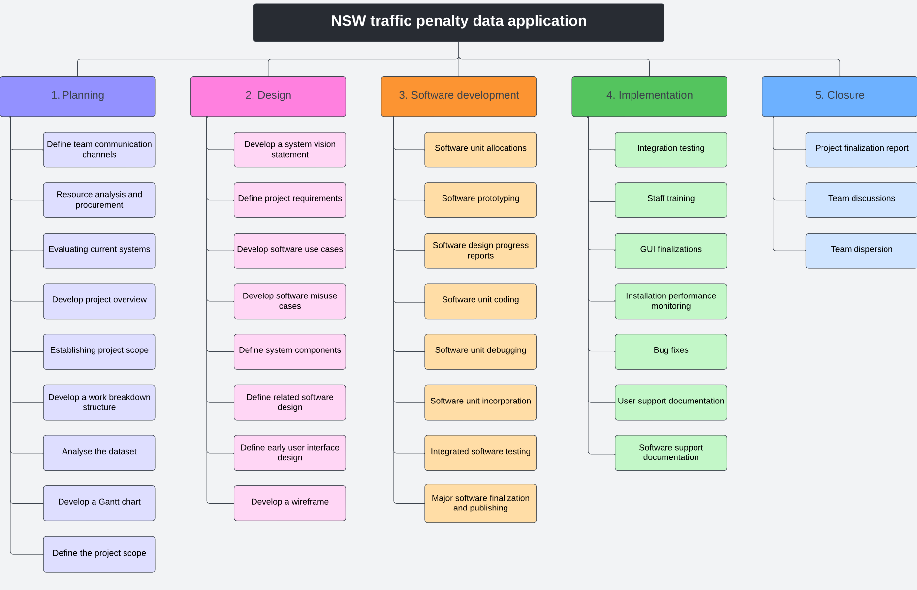

1. **Activity Definition & Estimation**

*From your WBS, define the activities required for your project. You will revise this document and add more detail for part B as you discover more about the project.*

*Each activity should be clearly identified by a number and should match up to your Gantt chart. You should provide some estimations for the time you think each activity will take. This should make it easy to prepare your Gantt chart.*

|  |  |  |
| --- | --- | --- |
| **Activity** | **Definition** | **Estimation** |
| **Stage 1 - Planning** |  | Planned start at period 1, and end at period 9. Duration of 9 periods. |
| 1.1 Define team communication channels | This activity involves developing a means of communication between team members. In this instance, discord was used as the primary communication channel. | Planned start at period 1, and end at period 2. Duration of 2 periods. |
| 1.2 Resource analysis and procurement | This activity involves evaluating and identifying resources required to achieve a goal. Additionally, the means to acquire goods or a service from an external source. | Planned start at period 1, and end at period 2. Duration of 2 periods. |
| 1.3 Evaluate current systems | This activity involves evaluating the current systems that are in place. This will provide data on if the system is meeting its objectives and design needs, and if improvement is required. | Planned start at period 1, and end at period 2. Duration of 2 periods. |
| 1.4 Develop a project overview | This activity involves developing a project overview that will provide a detailed insight into what the projects objectives are, the steps to achieve these objectives and the outcomes. | Planned start at period 1, and end at period 2. Duration of 2 periods. |
| 1.5 Establishing project scope | This activity involves developing a project scope that will briefly describe aspects of the project such as the projects goals, objectives, deliverables, activities, costs, constraints and deadlines. | Planned start at period 2, and end at period 5. Duration of 3 periods. |
| 1.6 Develop a work breakdown structure | This activity involves developing a work breakdown structure. A work breakdown structure (WBS) can be defined as structure used in large projects where tasks are broken down into smaller components and given measurable deadlines for completion. | Planned start at period 2, and end at period 6. Duration of 4 periods. |
| 1.7 Analyse the dataset | This activity involves analysing and familiarizing with the given dataset. | Planned start at period 1, and end at period 9. Duration of 9 periods. |
| 1.8 Develop a Gantt chart | This activity involves developing a Gantt chart for the project. The Gantt chart will outline each activity required to complete the project, rough estimations and actual finish time of each activity. | Planned start at period 1, and end at period 9. Duration of 9 periods. |
| 1.9 Define the project scope | This activity involves developing a project scope that will briefly describe aspects of the project such as the projects goals, objectives, deliverables, activities, costs, constraints and deadlines. | Planned start at period 2, and end at period 4. Duration of 2 periods. |
| **Stage 2 - Design** |  | Planned start at period 10, and end at period 20. Duration of 10 periods. |
| 2.1 Develop a system vision statement | This activity involves developing a system vision statement that will briefly describe the projects current and future objectives. | Planned start at period 10, and end at period 12. Duration of 2 periods. |
| 2.2 Define project requirements | This activity involves setting requirements for the project. These requirements will allow the project to be successful and fulfil the goals and objectives. | Planned start at period 10, and end at period 12. Duration of 2 periods. |
| 2.3 Develop software use cases | This activity involves developing a set of use cases. These use cases will describe how a user will perform scenarios within the software. This will outline the user's perspective and the systems behaviour as it responds to requests. | Planned start at period 12, and end at period 15. Duration of 3 periods. |
| 2.4 Develop software misuse cases | This activity involves developing a set of misuse cases. These cases will show examples of user misuses whilst operating the software. | Planned start at period 12, and end at period 15. Duration of 3 periods. |
| 2.5 Define system components | This activity involves specifying the components of the system. | Planned start at period 13, and end at period 14. Duration of 1 period. |
| 2.6 Define related software design | This activity involves outlining the relevant processes and steps taken to design the software. | Planned start at period 13, and end at period 16. Duration of 3 periods. |
| 2.7 Define early user interface design | This activity involves designing the early user interface of the software. It will describe style choices, features and design choices of the user interface. | Planned start at period 14, and end at period 17. Duration of 3 periods. |
| 2.8 Develop a wireframe | This activity involves developing a wireframe. A wireframe is a 2D, visual illustration of a web page or app interface. | Planned start at period 16, and end at period 21. Duration of 5 periods. |
| **Stage 3 - Software Development** |  | Planned start at period 21, and end at period 35. Duration of 14 periods. |
| 3.1 Software unit allocations | Software unit allocation involves distributing and allocating units of work for a software development team. | Planned start at period 21, and end at period 23. Duration of 2 periods. |
| 3.2 Software prototyping | Software prototyping involves modelling the envisioned product or software, to demonstrate its purpose and usability. | Planned start at period 23, and end at period 27. Duration of 4 periods. |
| 3.3 Software design progress reports | A software progress report that shows how the project has progressed. It shows completed and incomplete tasks. | Planned start at period 22, and end at period 24. Duration of 2 periods. |
| 3.4 Software unit coding | Software unit coding involves independently developing and coding each unit, which will build together to complete the software. | Planned start at period 22, and end at period 32. Duration of 10 periods. |
| 3.5 Software unit debugging | Software unit debugging involves detecting and resolving errors or bugs within a unit of code. | Planned start at period 22, and end at period 32. Duration of 10 periods. |
| 3.6 Software unit incorporation | Software unit incorporation involves forging the individually developed units of code together, to create the final form of the software. | Planned start at period 31, and end at period 33. Duration of 2 periods. |
| 3.7 Integrated software testing | This activity involves using different developed components of a software, combining them and testing all components as a complete program. | Planned start at period 32, and end at period 35. Duration of 3 periods. |
| 3.8 Major software finalization and publishing | This activity involves collecting, packaging and distributing the software. | Planned start at period 33, and end at period 35. Duration of 2 periods. |
| **Stage 4 - Implementation** |  | Planned start at period 35, and end at period 45. Duration of 10 periods. |
| 4.1 Integration testing | This activity involves using different developed components of a software, combining them and testing all components as a complete program. | Planned start at period 35, and end at period 38. Duration of 3 periods. |
| 4.2 Staff training | This activity involves training and briefing staff on the software and how to operate it. | Planned start at period 35, and end at period 40. Duration of 5 periods. |
| 4.3 GUI finalizations | This activity involves completing all graphics-based OS interface objects such as icons and menus. | Planned start at period 37, and end at period 40. Duration of 3 periods. |
| 4.4 Installation performance monitoring | This activity involves developing/ installing an application performance management tool (APM) to be able to monitor the performance of the software. | Planned start at period 38, and end at period 40. Duration of 2 periods. |
| 4.5 Bug fixes | This activity involves detecting and fixing potential errors or bugs within the software. | Planned start at period 40, and end at period 43. Duration of 3 periods. |
| 4.6 User support documentation | A user support documentation is a document that provides brief support on how to use the product, such as a guide or instruction manual. | Planned start at period 42, and end at period 44. Duration of 2 periods. |
| 4.7 Software support documentation | A software support documentation is a document that provides a brief guide for the user on how to successfully operate the software. | Planned start at period 43, and end at period 45. Duration of 2 periods. |
| **Stage 5 - Closure** |  | Planned start at period 45, and end at period 50. Duration of 5 periods. |
| 5.1 Project finalization report | A project finalization report is a report that briefly describes the outcomes of the project and if goals and objectives have been successfully complete. | Planned start at period 45, and end at period 47. Duration of 2 periods. |
| 5.2 Team discussions | This activity involves the discussion between team members on how the project went. | Planned start at period 46, and end at period 49. Duration of 3 periods. |
| 5.3 Team dispersion | This activity involves the separation of the team as the project has been complete. | Planned start at period 49, and end at period 50. Duration of 1 periods. |

1. **Gantt Chart**

*This section should contain your Gantt chart. The items in the Gantt chart should match the activity definition from section 3. You should also submit your Gantt chart file separately.*

1. **Bibliography**

Noble, F. (2022, January 19). *Fines issued in NSW last year surge to almost $1 billion worth despite lockdowns*. 9NEWS: https://www.9news.com.au/national/fines-issued-in-nsw-last-year-surge-to-almost-1-billion-dollars-worth-despite-covid-19-lockdowns/f30b5b99-beb3-4536-ba67-e51c56adee56